Getting Started with Apache Airflow

Ashish Kumar | Associate Consultant
Neudesic | The Trusted Partner in Business Innovation
Cell: 8801737804

This document is available at: https://github.com/iAshishHere/Apache-Airflow Updated Jan 2019,

Table of Contents
What is Apache-Airflow 3
Other similar tools 5
Advantages 5
Disadvantages 7
Getting started with Apache Airflow 8
Sample Code 9
Operators 12
Sensors 12
Trigger Rules 12
XCom 13
Reference 13

What is Apache-Airflow
Apache Airflow is an open-source tool for orchestrating complex workflows and data processing pipelines. It is a platform to programmatically schedule, and monitor workflows for scheduled jobs.
Apache airflow make your workflow simple, well organized and more systematic which can be easily authored and schedules based on requirement.
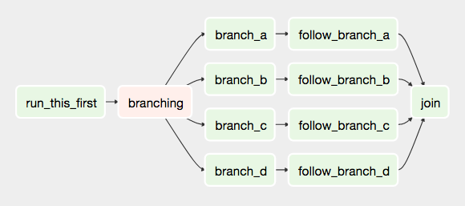
Code is written in Python, once your workflow is defined, it becomes more maintainable.
It has got a rich UI interface, which gives good visualization of workflow.

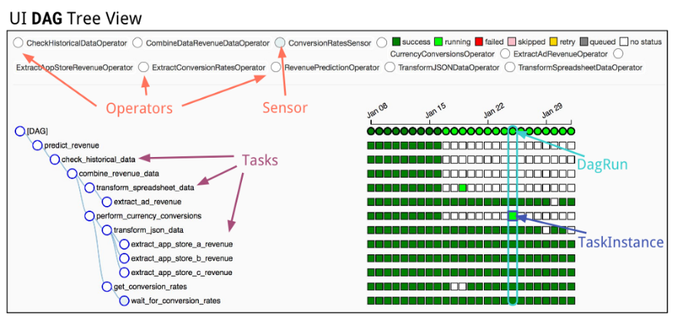

What do we mean by a workflow?
Workflow can be your simple calculation, creating infrastructure, perform some query in the database, bash command, python script, MySQL queries, Hive queries, etc.
Workflow are divided into one or more than one tasks which are connected with each other and forms a DAG (Directed Acyclic Graph).

What is DAG?
In simple terms, DAG is a collection of all small task which joins together to perform a big task.
Still Confused? Let’s understand by an example.

Let us take an example of Phases of Compiler.
This is what happen after compiling a piece of code. Our code gets converted into character stream, Lexical Analyzer converts it into tokens, then syntax analyzer convert it into syntax tree, then semantic analyzer, intermediate code generator, code optimization, target assembly code. Here each step is very crucial and very much dependent on the previous steps.
Error in any one of the step will not compile our code successfully.
How these steps would look in DAG?

Here diagram of some dag.

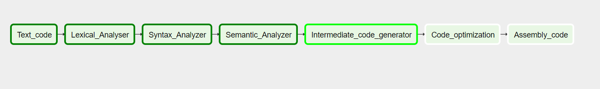

If your task is dependent on some other task, you can set dependencies based on your requirement. Will discuss this briefly in getting started with Apache-airflow.
What is scheduled jobs?
Suppose your workflow has to be run on every Sunday, you can schedule it in such a way that it will only be trigger on Sundays. How cool is this?
In simple terms you can automate your workflow. The best part of automation is you can avoid future human errors.
Your DAG can be easily monitored, controlled and triggered.
What if your workflow get fail? What if it got completed successfully? What if it took more than the expected time to complete?

Well, keeping all such things in mind, apache-airflow has given such features like: If your workflow gets fail, you can set it as to send Email alert, slack notification to the required person/team.
You can also set it to send email when the DAG ran successfully.
What if your task got successfully run, but took more than expected time. (In real case scenario this is a problem) – For this you can set your SLA. Suppose your SLA time is 600 seconds. But your task took 900 seconds. Isn’t it something wrong? If this happens, it trigger to the required team

Other similar tools
- Cron
- Apache Oozie
- Luigi
- Azkaban

Advantages
Apache-airflow has got quite a few advantages which makes it a better tool then compare to other tool in the market.
First we’ll discuss its advantages and then few benefits of using airflow over other similar tool.

- Open Source / Python - The code is completely in Python and it’s very easy to design your own workflow. You can contribute your own plugins in open source and also use other plugins based on your requirement.

- Monitoring – You can easily monitor your task status once it is running. Airflow provides all the necessity details of each task such as execution time, landing time, logs, etc.

- Scalable – Mostly all the data driven companies prefer to use Airflow, so it’s obvious that the complexity of workflow will grow as moving ahead. But airflow holds the advantage over other tool as it’s more scalable.

- Smart Scheduling – You can schedule your task however you want to. Example if you want to schedule your task to run on every Sunday at 4:00 PM, you can do it.

- Managing Dependency – One of the cool feature which makes airflow better than all other tool is proper management of dependency. If a task t2 is dependent on task t2 which is further dependent on task t0, you can set dependency across.

- Resilience – All workflow tools sometimes behave unexpectedly, may it be any reason such as network issue, human error, taking longer time than expected, etc. Airflow as several features such as retry. If by any chance, your task failed to execute, airflow retires it after certain minute, (If it might have failed due to other reason such as network issue, then retry might make that task successful).
It even give alert message to the team via email/slack.

- Alerting – This is one of the coolest feature airflow has, if you want your team should get notified if any of your tasks gets fail, it will notify via Mail, slack notification.
Even if your task gets successful, you may want to get notified, airflow has that feature too.

- Service Level Agreement (SLA) Timeout: This might be one of the most crucial feature (Al least for some company) which airflow has provided. If your task takes generally 500 sec to finish, but one certain day, it took 1500 seconds, don’t you think something unexpected happened?
Wouldn’t you like to get notify? You may have your own reason to store these records, may be for analytic purpose or any other research work.
Example: Suppose your company collects user registration data at the end of the day, but you have notices that on every Saturday your task it taking a lot of time that means people on Saturday are more to participate.

- User Interface – It has a good UI which makes it more approachable for the user. You can view the task in well formatted tree structure, you can view the logs details, airflow database, task duration, lading times, rich graph view in UI.

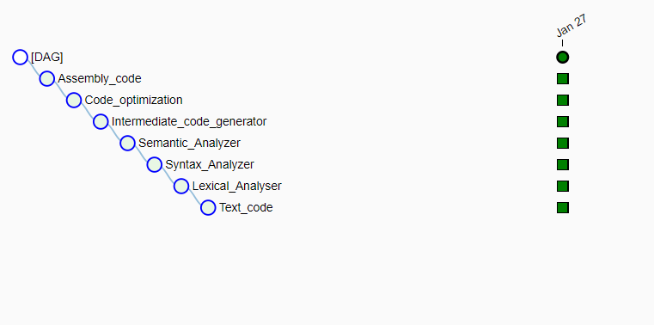
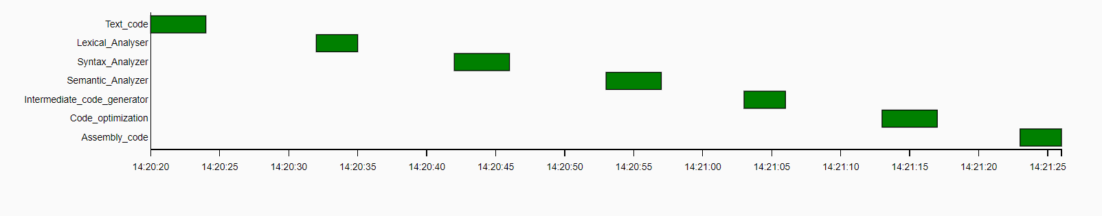

- Plugins and hooks - Airflow has got various pre define plugins and also user defined plugins which makes your task easy.

- Custom plugins, hook, sensors – I will get back to you about these keywords such as plugins hook sensors etc. In short we can make our own operators in airflow and manipulate it to work as we like it to behave.

- Cloud services - Cloud platforms like Google cloud shows its support to apache- airflow. Cloud composer – is a google service which creates an environment of apache – airflow in google cloud. You can perform almost everything and use cloud services such as big query, dataproc, dataflow etc.

Mentioned above are quite a few advantages which I personally felt very useful. It might have many advantages as well as few disadvantages.

Disadvantages
While working with Pandora media, I found few things which was troubleshooting and created problem, so we had to look for different alternative. This might not be in every one case, but we faced few issues.

- Not every operator in airflow will work how you expect it to work – Few operator which is already defined by airflow doesn’t work as we expect it to work. But not to worry, we can do few manipulation in their code and can make custom plugins to make it work.
- We were using Cloud Composer (google cloud service) which creates environment for apache airflow in cloud. We got to see many unexpected issue, now some of this might was from airflow and some were from google side. That might be fixed in later updates.

Following were the major issues in cloud composer:

- DAG not getting scheduled – Sometimes your DAG will not get schedules and will not be recognize by apache airflow. Now this is because it doesn’t get update on apache server. Or there might be some error in your DAG code whose details is not given by apache airflow. You need to figure it out by yourself.
Sometimes it also looks into the cache without updating the new one.

- Sometimes even after installing PYPI packages, it is not recognized by apache airflow.

- Cloud composer consumes lot of time to create environment, any sort of update will again take a lot of time.

- One of the major issue I want to highlight which we faced and based on research we analyzed many other developers are facing the same, is SLA timeout alerting.
In our case whenever any of our task got timeout, it was sending the alert message but not triggering the very next task, which in ideal case shouldn’t happen
so we came up with another approach to solve this issue which probably I will show you somewhere.

Getting started with Apache-Airflow

Let’s get started with some practice knowledge and start creating our own sample workflow.
I will be using cloud composer to create airflow environment. We can also create local environment.
As soon as you create a cloud composer, it creates a bucket in your cloud storage automatically, which has somewhat similar folder structure.

airflow_home (Airflow Bucket)
├── airflow.cfg
├── airflow.db
├── plugins
├── dags <- Your DAGs directory
│ └── hello_world.py <- Your DAG definition file
└── unittests.cfg

In the DAG folder you need to upload all your python script or DAG which will get rendered into airflow server and show in the UI and then you can trigger it manually or if scheduled, it will trigger automatically.

Sample Code
from datetime import datetime
fom airflow import models
from airflow.operators.bash_operator import BashOperator

yesterday = datetime.datetime.combine(
datetime.datetime.today() - datetime.timedelta(1),
datetime.datetime.min.time())

default_dag_args = {
'start_date': yesterday,
'email_on_failure': False,
'email_on_retry': False,
'retries': 1,
'retry_delay': datetime.timedelta(minutes=5),
'project_id': models.Variable.get('gcp_project')
}

with models.DAG(
‘Bash_operations’,
schedule_interval=datetime.timedelta(days=1),
default_args=default_dag_args) as dag:

t1 = BashOperator(
task_id=’Make directory’, bash_command=’mkdir folder_name’, dag=dag)

t2 = BashOperator(
task_id=’delete directory’, bash_command=’mkdir folder_name’, dag=dag)

t1 >> t2 #-→ This is how we set dependency among two tasks.

Let’s us understand this code line by line.

from datetime import datetime
from airflow import models
from airflow.operators.bash_operator import BashOperator

These are the import statements for the facility which we are using in our DAG.
We need to import
Since we are using BashOperator we need to import BashOperator from airflow library.

default_dag_args = {
'start_date': yesterday,
'email_on_failure': False,
'email_on_retry': False,
'retries': 1,
'retry_delay': datetime.timedelta(minutes=5),
'project_id': models.Variable.get('gcp_project')
}

These are the default argument which we can set for each task by setting argument to each task’s constructor. We can define a dictionary of default parameters that we can use when creating tasks.

Start_date as yesterday means start as soon as it loaded into the server. We can set it at any time.
Email_on_failure as False, if it is true it will send email to the specified person/team if any particular task gets fail.
Retries as 1 means the number of retries after the task get fails.
Retry_delay is set as 5 minutes means, after any specific task gets fail, it should wait exactly 5 minutes to start a retry.
Email_on_retry as False, if it is true, then after a task get fail, after every retry it will send email to the specified person/team.

For more information about the BaseOperator’s parameters and what they do, refer to the airflow.models.BaseOperator documentation.

In DAG everything works as an operator. Example t1 = SomeOperator(arguments).

We are using Bash Operator in this example.

t1 = BashOperator(…)
task_id=’Make directory’,
bash_command=’mkdir folder_name’,
dag=dag)

t1 = BashOperator(…)

t1 is a value which is calling BashOperator class and sends all the required arguments to it.
Every task has a task_id which uniquely defines a task, and other required arguments based on what operator you are using.

In our DAG, we are running two different task such as t1 and t2, one is creating a directory and other is deleting the directory.
So, its obvious t1 has to be run before t2, so we have set dependency such as t1 must run before task t2.
There are two ways to set dependency:
- T1 >> T2 (This means T1 will run before t2)
- T1.upstream(T2) (This also means the same as above)

In order to do vice-versa the syntax would be like this:
T1 << T2
T1.downstream (T2)

Finally we need to place our .py file into DAG folder and then it will get loaded into server.

You can see the task graph view as:

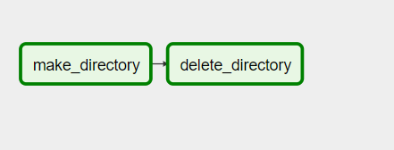

The arrow denotes that make_directory is dependent on delete_directory.

Well this was a very simple example of how we create tasks, and run the workflow.

Operators
While DAGs describe how to run a workflow, Operators determine what actually gets done.
An operator describes a single task in a workflow. Operators are usually (but not always) atomic, meaning they can stand on their own and don’t need to share resources with any other operators.

Note: If two operators need to share information, like a filename or small amount of data, you should consider combining them into a single operator. If it absolutely can’t be avoided, Airflow does have a feature for operator cross-communication called XCom.

Airflow provides many operators some of them includes:
- BashOperator (Which we just saw)
- PythonOperator – Use to call any python function in DAG
- EmailOperator – Sends email
- SimpleHttpOperator – Sends a HTTP request
- MySqlOperator, SqliteOperator, PostgresOperator, OracleOperator, JdbcOperator - executes SQL queries.

Sensors
Sensors are special type of operator which runs behind the scene all the time. Sensor class is created by extending BaseSensorOperator.
It has a poke method, which execute the task over and over after every poke_interval seconds until it returns True and if it returns False it will be called again.

Example: Sensor to check whether a file is present in a specified directory. After every poke_interval, the poke method of the sensor class will be executed, if the file in not present it will send False, once the file is present in the directory, it will return True.

Trigger Rules
All operators have a trigger_rule argument which defines the rule by which the generated task get triggered. The default value for trigger_rule is all_success and can be defined as “trigger this task when all directly upstream tasks have succeeded”. All other rules described here are based on direct parent tasks and are values that can be passed to any operator while creating tasks:

- all_success: (default) all parents have succeeded
- all_failed: all parents are in a failed or upstream_failed state
- all_done: all parents are done with their execution
- one_failed: fires as soon as at least one parent has failed, it does not wait for all parents to be done
- one_success: fires as soon as at least one parent succeeds, it does not wait for all parents to be done
- none_failed: all parents have not failed (failed or upstream_failed) i.e. all parents have succeeded or been skipped
- dummy: dependencies are just for show, trigger at will

XCom (Cross – Communication):
Communication among two operator. If any operator returns some value, it get store in xcom, airflow provides a mechanism to pull xcom value using xcom_pull() and use it in some other operation and also to puch value usins xcom-push().
Example: View code in Github https://github.com/iAshishHere/Apache-Airflow/blob/master/Xcom_example/Xcom_example.py

Reference
Airflow Documentation
- https://airflow.apache.org/
Apache-Airflow GitHub
- https://github.com/airflow-plugins
To see some example code visit my GitHub
- https://github.com/iAshishHere/Apache-Airflow

